**Exam Number 1**

**Subject: Nuclear Fuel Cycle**

**Number of Questions: 5**

**Number of Sub-questions: 11**

**Q1)**

1. Which of the following isotopes is a common fission product and a significant contributor to radioactivity of spent nuclear fuel?
2. Uranium-235
3. Plutonium-239
4. Cesium-137
5. Thorium-232
6. In the nuclear fuel cycle, the PUREX process is used for:

a) Enriching uranium

b) Fabricating fuel elements

c) Reprocessing spent nuclear fuel

d) Disposing of high-level waste

1. Which of the following is an advantage of using a closed nuclear fuel cycle over an open nuclear fuel cycle?

a) Less nuclear waste is generated

b) No enrichment of uranium is required

c) No need for spent fuel storage

d) No possibility of nuclear weapons proliferation

1. What is the minimum percentage of U-235 enrichment generally considered to be weapons-grade?

a) 20%

b) 50%

c) 75%

d) 90%

1. Which international organization is primarily responsible for monitoring and verifying the peaceful use of nuclear technology and ensuring compliance with nonproliferation agreements?

A. International Atomic Energy Agency (IAEA)

B. United Nations Security Council (UNSC)

C. Comprehensive Nuclear-Test-Ban Treaty Organization (CTBTO)

D. North Atlantic Treaty Organization (NATO)

1. Why is plutonium considered a very dangerous material in the realm of non-proliferation and SNF reprocessing?

**Q2)**

1. What are the benefits of the Reprocessing and Recycling?

1. What are the advantages of the Thorium fuel cycle?

**Q3)** A nuclear power plant has a capacity of 1000 MWe and operates at a capacity factor of 80%. The reactor requires 3.2% enriched uranium as fuel. The enrichment process has a tails assay of 0.25%. Calculate the amount of natural uranium (in tons) needed to fuel the reactor for one year assuming that the reactor’s burnup is 1 GWd/MTU?

**Q4)** The figure below crudely shows the decay of SNF activity overtime. Estimate the overall effective half-life of this spent nuclear fuel pile assuming that the best fit for this curve is an exponential function?

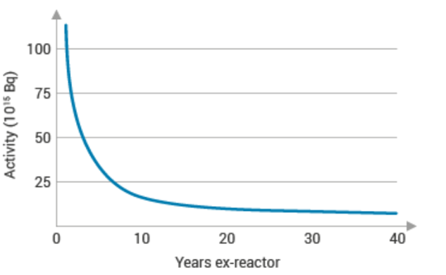

Figure . Activity Decrease over time (in units of 10^15 Bq)

**Q5)** Question: A 1000 MWe maximum rating nuclear power plant has been operating for a period of 120 days with the following power history:

| Day | Power Output (MWe) |

|------------|--------------------|

| Day 1-10 | 600 |

| Day 11-30 | 900 |

| Day 31-70 | 750 |

| Day 71-100 | 800 |

| Day 101-120| 950 |

Calculate the effective full power days (EFPD) burnup of the nuclear power plant for this period.

**Exam Number 2**

**Subject: Nuclear Engineering Materials**

**Number of Questions: 7**

**Number of Sub-questions: 21**

**Q1)**

1. Which of the following undergoes radiation growth (check all those apply).

|  |  |  |  |  |  |  |
| --- | --- | --- | --- | --- | --- | --- |
| Metallic fuel | -U | -U | -Pu | -Pu | -Th | -Th |
| Check √ all those apply |  |  |  |  |  |  |

1. What are the advantages of metallic fuels (check all those apply)
2. Complete table 1 below, for the comparison between metallic and ceramic fuels.

Table 1 (comparison between metallic and ceramic fuels)

|  |  |  |
| --- | --- | --- |
| Parameters | **Metallic fuels** | **Ceramic fuels** |
| Neutron economy |  |  |
| Thermal conductivity |  |  |
| strength |  |  |
| Thermal expansion |  |  |
| Corrosion resistance |  |  |
| Radiation stability |  |  |
| Melting point |  |  |

1. What are basic requirements of nuclear fuel?

**Q2)**

1. True or False Questions:

( ) Creep occurs in structures subjected to dynamic mechanical stresses while maintaining the temperature constant.

( ) Fatigue failure occurs at a stress level considerably lower than the tensile or yield strength for a static load.

( ) The volume of materials undergo void swelling remains constant.

( ) The smaller the grain size the less a material’s resistance to creep.

2. An 8.0 mm diameter cylindrical rod fabricated from a red brass alloy (see figure below) is subjected to reversed tension–compression load cycling along its axis. If the maximum tensile and compressive loads are +7500 N and −7500 N, respectively, determine:

1. Mean Stress
2. Stress Range
3. The stress amplitude in MPa
4. Its fatigue life

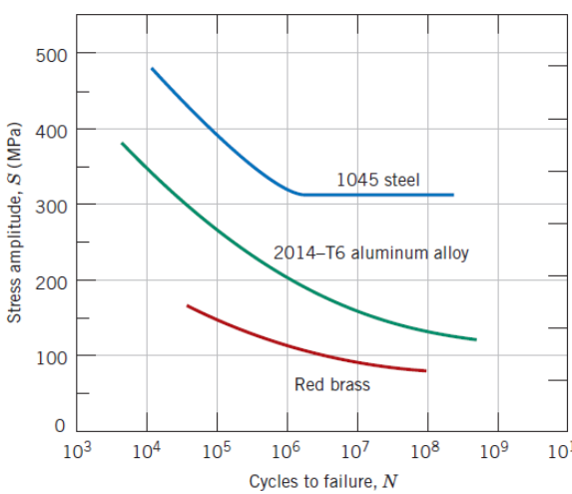

**Q3)**

1. State the differences between Frenkel Defect and Schottky Defect:
2. State the difference of edge dislocation and screw dislocation?
3. Calculate the number of vacancies per cubic meter in copper at 7500C. The energy for vacancy formation is 0.74 eV/atom. The density and atomic weight for Fe are 8.96 g/cm3 and 63.54 g/mol, respectively.

**Q4)**

1. A hypothetical element has a cubic structure with a lattice constant of 7.6084 Å. If its atomic weight is 1646.56 g/mol and the mass density is 12.42 g/cm3. Calculate how many atoms does its unit cell have? What kind of crystal structure it would be?

a=3.8042 A0

A=1646.56 g/mol

ρ=12.42 g/cm3

2. Using the data in the table below, which ones have higher mobility:

a. Interstitials and Vacancies of Al

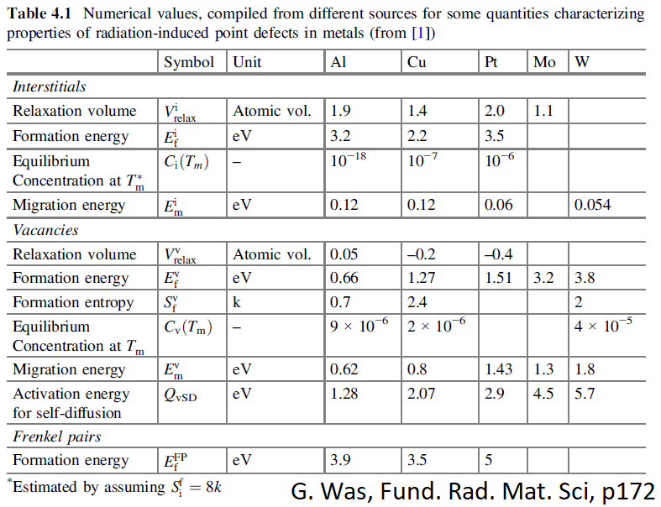b. Interstitials of Cu and Interstitials of Pt

**Q5)**

1. The figure below shows the relationship between stress and strain. Fill out the table below:

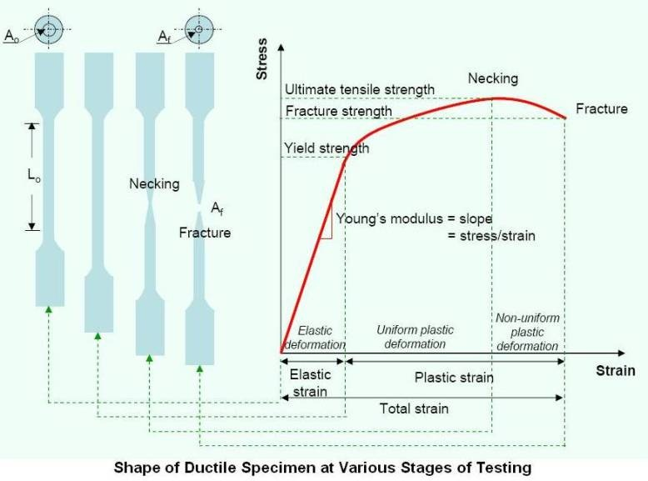

a

b

c

d

e

Strain

f

g

Table 2 (Stress and Strain Curve)

|  |  |
| --- | --- |
|  | Stress and Strain Curve |
| a |  |
| b |  |
| c |  |
| d |  |
| e |  |
| f |  |
| g |  |
| h |  |

1. A piece of copper with 150 mm long is pulled in tension with a stress of 250 MPa. E of copper is 110 GPa. If the deformation is entirely elastic, what will be the resultant elongation?

**Q6)**

1.State the definition of:

1. Primary knock-on atom
2. Thermal spikes
3. Depleted zones
4. Cavities
5. Displacement threshold energy

2. The figure shows the creep strain as a function of time for different applied stresses. Write down three observations you notice from the figure with increasing the stress values.

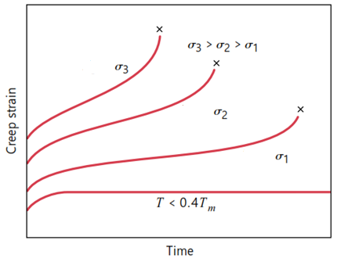

**Q7)**

The metal iridium has an FCC crystal structure with lattice constant of 3.835 Å. If the angle of diffraction for the (*h k l*) set of planes occurs at 69.20° (first-order reflection) when a monochromatic x-radiation having a wavelength of 1.54 Å is used.

1. Calculate the interplanar spacing d*hkl* for this set of planes.
2. Determine the miller indices of this set of planes (*h k l*).

**Exam Number 3**

**Subject: Nuclear Power Reactors**

**Number of Questions: 5**

**Number of Sub-questions: 15**

**Q1)** A BWR core consists of 30,000 fuel rods; each fuel rod has an active length of 12 feet. The core is producing 1,800 MW of thermal power. If the total peaking factor for a node is 2.0, what is the maximum local linear power density being produced in the node?

**Q2)**

1. Estimate the cost per kWh of the energy unit generated from a reactor unit with 60 years life expectancy, 1400 MWe maximum power rating and a gross capital cost of 5 billion USD, O&M overall cost 1 billion USD, fuel cost 0.5 billion USD and availability factor of 95%.
2. Why it is advisable to run the NPP at its full capacity. Plot the approximate relation between the efficiency and NPPs power output?

**Q3)** Given the data below, answer the questions A through C :

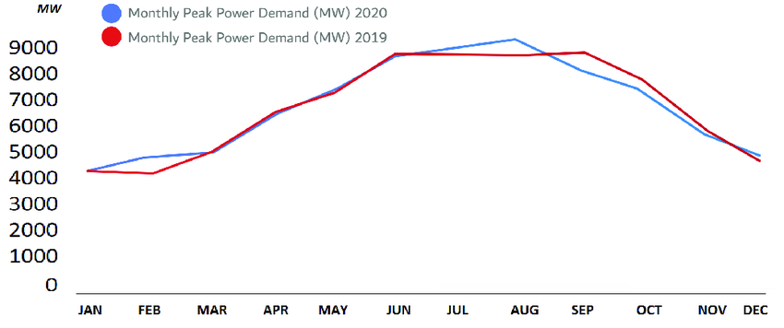

Figure . Dubai Monthly Peak Power Demand Curve.

1. Explain the high demand in Dubai during the months May-OCT?
2. Estimate the monthly base load in Dubai ?
3. Estimate the peak loads for both 2019 and 2020 based on the data represented in the figure?

**Q4)** A BWR operating under 7 MPa pressure and 1200 kg/s of saturated steam with feed water at 200 oC and downcomer recirculation mass flow rate of 10800 kg/s. Answer the following:

1. Sketch a full BWR power cycle
2. The recirculation ratio?
3. Average exit quality of the core coolant
4. The core inlet water thermodynamic quality
5. If the power plant has an efficiency of 1500 MWth to the condenser cooling water with a thermal capacity of 4.18 kJ/kg°C. The mass flow rate in the condenser is about 30,000 kg/s and the reservoir water temperature is 25 oC. What is the estimated temperature increase in the condenser’s cooling water?

**Q5)**

1. List 3 applications for the the high outlet temperature of the helium coolant (in VHTGR) makes it possible to?
2. Explain the difference between breeder, converter and burner reactors
3. Why Cs and I isotopes are considered of special environmental concern if radioactive released due to an accident
4. Explain the ALARA principle and what is its purpose?

**Exam Number 4**

**Subject: Nuclear Instrumentation and Measurements**

**Number of Questions: 4**

**Number of Sub-questions: 18**

**Q1)**

1. A screenshot of a computer

   Description automatically generatedA simple experiment was performed to study the gamma-ray attenuation properties of an absorber material. The geometrical setup is shown in the figure where the source is placed in the lead shield. Given the following:

**vacuum**

**vacuum**

* the source undergoes beta decay to an excited state of the daughter nucleus
* the daughter nucleus decays by emitting a gamma ray with energy 511 KeV

**Gamma detector**

* the absorber thickness is 2 cm (precisely measured)
* the detector reads 2000 counts in 20 minutes with the absorber present
* the detector reads 2500 counts in 10 minutes without the absorber present
* the background counts are negligible

**Answer the following:**

1. Calculate the linear attenuation coefficient of the absorber material
2. What is the probability per unit distance that the gamma rays do not interact in the absorber material?
3. During the 20-minute measurement, if 10 gamma rays scatter in the absorber and are counted in the detector with the 2000 counts, what is the value of the build-up factor?
4. Cs-137 beta decays to an excited state of Ba-137, which eventually decays to the ground state of Ba-137 by emitting a 0.662 MeV gamma-ray. If the following experimental setup is used to detect the gamma rays, determine the energy deposited in the detector for the three different cases shown in the figure. Clearly state any assumptions you make.

NaI Detector

Lead Shield

90O

45O

**Q2)**

1. Why does the pulse height from a Geiger tube continue to increase with applied voltage even after a full Geiger discharge is obtained?
2. Explain two advantages and two disadvantages of the following detectors:

i) High Purity Ge detectors

ii) Gas-filled Geiger-Muller counters

1. A beam of alpha particles produced a current of 10–14 A in a parallel-plate ionization chamber filled with helium for 6 s. If the first ionization potential for helium is 24.5 eV and the average energy to create an ion pair in helium is 42.7 eV,
2. Calculate the charge produced
3. Calculate the energy deposited in the chamber in Joules

**Q3)**

**a.** One of the commonly reactions in detecting slow neutrons is the following:

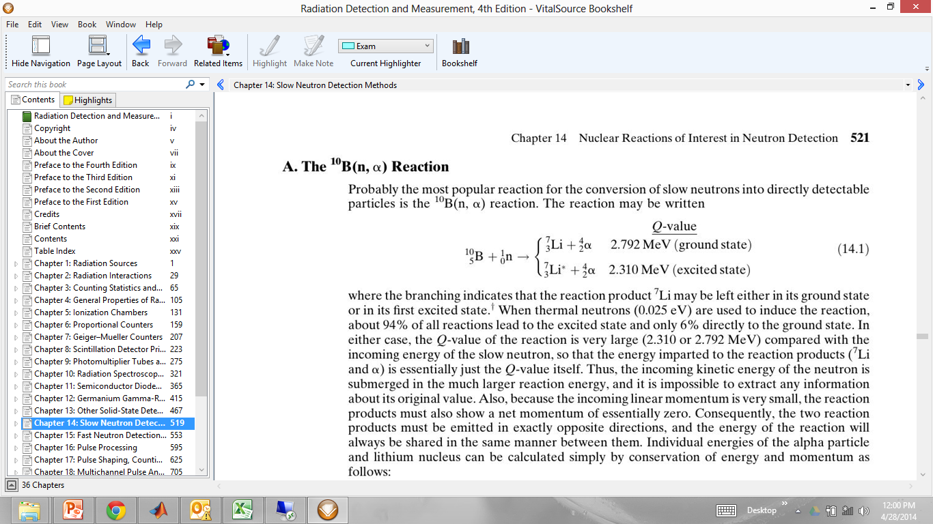

94%

6%

When using an intermediate size BF3 proportional tube to detect slow neutrons, the following spectrum may result:

1. Thoroughly explain all the features and peaks in this spectrum.
2. What is the “Wall effect” and how does it occur?

**b.** A cylindrical proportional tube has an anode wire radius of 0.0025 cm and a cathode radius of 1.8 cm. It is operated with an applied voltage of 2200 V.

1. Calculate the electric field in the tube at radii 0.00025 and 0.00155 m.
2. If the minimum electric field to initiate gas multiplication is 1.0 MV/m, what is the maximum radius for gas multiplication to occur?



**Q4)**

**a.** The figure below shows a typical arrangement of a photomultiplier tube. Explain the function of:

1) Photocathode

2) Glass envelope

3) Dynodes

4) Anode



**b.** A beam of collimated neutrons of energy 4 eV is incident on a BF3 detector. Given the following:

Neutron source

BF3 Detector

1. BF3  detector length = 20 cm
2. BF3  detector radius = 1.5 cm
3. Boron-10 atoms density= 1.7x1019 cm-3
4. absorption cross-section of 4 eV neutrons in

B-10 is approximately 310 barns

Calculate the efficiency of this detector for these neutrons.

**Exam Number 5**

**Subject: Nuclear Instrumentation and Measurements**

**Number of Questions: 3**

**Number of Sub-questions:10**

**Q1)**

1. For each of the radiation sources listed below, indicate whether "discrete" or "continuous" is a better description:
2. Conversion electrons
3. Auger electrons
4. Fission fragments
5. Bremsstrahlung
6. Annihilation radiation
7. Using the reaction below, find the energy released by the spontaneous fission of 235U into two equal-mass fragments.

235U 🡪 117Sn + 118Sn

**Q2)**

1. Calculate the mean free path of 1 MeV gamma rays in sodium iodide (specific gravity= 3.67, and the mass attenuation coefficient is 0.06 cm2/gm).
2. What fraction of 2-MeV betas will go through a single Al (density = 2.7x103 kg/m3) foil of thickness 0.1 mm? Where; μ = 0.7714 m2/Kg

**Q3)**

1. A 10-min count of a source+ background gives a total of 846 counts. Background alone counted for 10 min gives a total of 73 counts. What is the net counting rate due to source alone, and what is its associated standard deviation?
2. Explain in your words the term, “Minimum Detectable Activity”.

**Exam Number 6**

**Subject: Nuclear Reactor Physics**

**Number of Questions: 6**

**Number of Sub-questions:11**

**Q1)** A material has been discovered with a total thermal neutron cross section of 1200 barns, a neutron capture cross section of 250 barns, and a neutron scattering cross section 27 barns. Based on the information given, is it possible that this is a fissile material and what is the probability of fission interaction?

**Q2)** Suppose that a fissile material is discovered for which all the neutrons are prompt. Furthermore,

suppose that a reactor fueled with this material has a prompt neutron lifetime of 0.002 s.

1. If the reactor is initially critical, and there is no source present, what period should the reactor be put on if it is to double its power in ten seconds ?
2. What is the value of the multiplication factor () in this case ?

**Q3)** Given the Data below answer questions A and B:

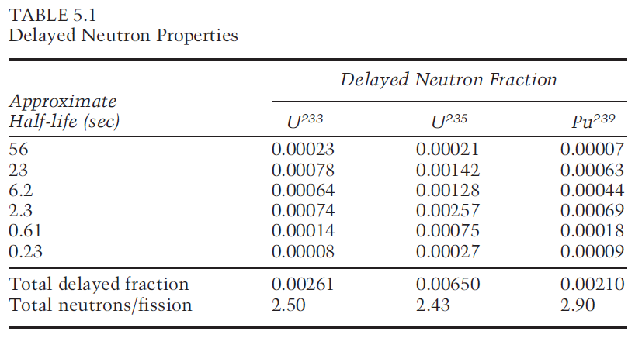

1. A power reactor is fueled with slightly enriched uranium. At the middle of core life 10% of the power comes from the fission of the built-up plutonium-239. Calculate the effective value of at the beginning and at the end of core life; determine the percent increase or decrease.
2. Calculate the reactivity (in units of $ and ) of the reactor above (initially critical) if its multiplication factor suddenly becomes .

**Q4) Long term core behavior**

1. Write down the balance equation(s) for Xe-135
2. Derive an expression for the steady state concentration of Xe-135 and I-135 based on the above-mentioned schemes?

**Q5)**

1. The moderator temperature coefficient for a reactor is -12 pcm/ °F. Calculate the reactivity defect that results from a temperature decrease of 10°F.
2. Plot approximate figures (with relative units) showing the differential and integral rod worth as a function of the insertion depth in the core (y-axis: the rod worth, x-axis: fraction distance from bottom of the core )?

**Q6)** Consider a thermal reactor with the 6 factors’ values below:

, , , , ,

1. Estimate the multiplication factor of this reactor?
2. If the non-fuel thermal neutron absorption cross section increase by 10% in total, which factor will be affected by this change and what would be the updated value of the multiplication factor?

**Exam Number 7**

**Subject: Nuclear Reactor Physics**

**Number of Questions: 11**

**Number of Sub-questions:29**

Q1)

1. What is the reaction rate?
2. A monoenergetic beam of neutrons, = 4 × 1010 neutrons/cm2-sec, impinges on a target 1 cm2 in area and 0.1 cm thick. There are 0.048 x 1024 atoms per cm3 in the target, and the total cross-section at the energy of the beam is 4.5 b.

Calculate the macroscopic total cross-section and number of neutron interactions per second occur in the target.

**Q2)**

1. Write the 4-factor formula and define each factor

b) In a thermal nuclear reactor at the beginning of its life for every 1,000 neutrons, 500 neutrons are absorbed in 235U, 225 neutrons are absorbed in 238U, 125 neutrons are absorbed in coolant and cladding, 150 neutrons leak out from the geometrical core boundaries, and ν is 2.43.

Calculate the multiplication factor and the conversion ratio value for this reactor

**Q3)**

a. Complete the following neutron transport equation:

Leakage

Source

In-scattering

b. Three isotropic neutron sources, each emitting *S* neutrons/sec, are located in an infinite vacuum at the three corners of an equilateral triangle of side *a*.

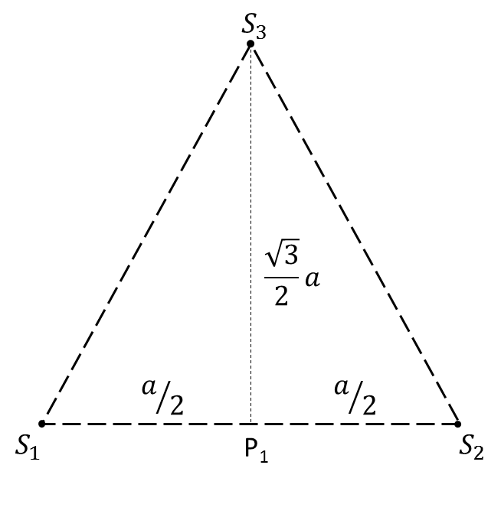Find the flux at P1 - the midpoint of one side.

Flux of point source in infinite medium:

Q4) A plane source of strength neutrons/sec is placed in an infinite medium. The material has an absorption cross section and a diffusion coefficient . Neglect the extrapolation distance.

* 1. Write down the diffusion equation and its general solution for this problem for

.

* 1. Solve the general equation for by applying 2 following conditions:

Q5) For a cylindrical shape reactor with the following information:

* Initial boron concentration = 2200 ppm
* of Boron = 600 b, of Boron = 0 b.
* Mass number of boron = 10.811
* For water, =0.035 /cm, =0.00 /cm, =0.050 /cm
* For fuel, =0.650 /cm, =0.40 /cm, =0.040 /cm, =2.5
* Fuel to Moderator volume ratio= 1/3
* Avogadro number = 6.022x1023 atom/mole
* Power=1000 MWth
* Do not neglect the extrapolation distance.

Answer the following equation using 1-group diffusion theory:

* + 1. Calculate for a mixture of fuel, water, and boron.
    2. Calculate the diffusion coefficient.
    3. Find a geometrical buckling that makes the reactor critical.
    4. If the diameter of the reactor is 150 cm, calculate the critical height of cylinder.
    5. Calculate the leakage to absorption ratio.
    6. Calculate the average neutron flux in the reactor.
    7. Calculate the maximum neutron flux in the reactor.

**Q6)** Diffusion equation for group g is written as follows:

a. Explain the meaning of each term of the equation

b. Write down the multigroup diffusion equation for steady-state condition.

c. Write down the steady-state multigroup diffusion equation in case the fission source is much more dominant compared to the external source.

Q7)

1. What is neutron multiplication factor?
2. Complete of the following chart of neutron life cycle

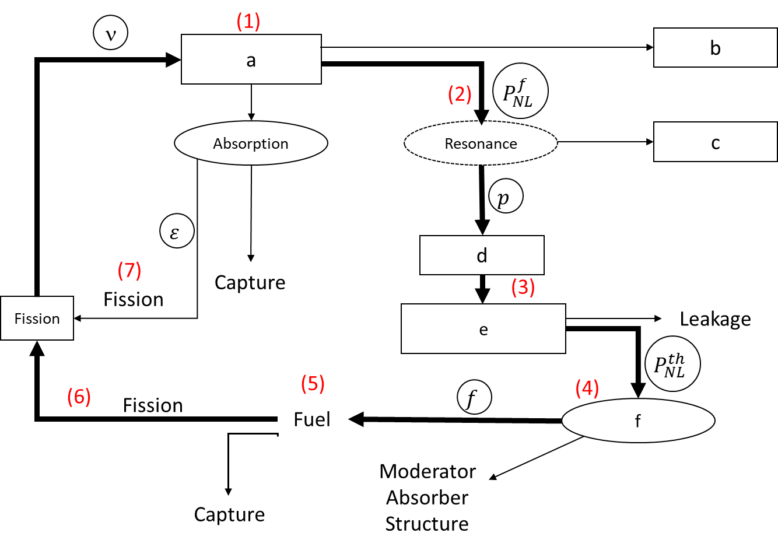

|  |  |
| --- | --- |
|  | Write your answer here |
| a |  |
| b |  |
| c |  |
| d |  |
| e |  |
| f |  |

Q8) The neutron transport equation in its complete form is

a) In Equation (1), what is the scattering term and what is the leakage term?

b) Simplify Eq. (1) for one-speed neutron

c) Simplify Eq. (1) for one-group energy steady state

Q9) In a thermal nuclear reactor at the beginning of its life for every 1,000 neutrons, 450 neutrons are absorbed in 235U, 225 neutrons are absorbed in 238U, 125 neutrons are absorbed in coolant and cladding, 200 neutrons leak out from the geometrical core boundaries, and ν is 2.43.

1. Calculate the multiplication factor for this reactor.
2. What is the conversion ratio value for this reactor?
3. The control rods are then inserted such that now 410 neutrons are absorbed in 235U, 215 neutrons are absorbed in 238U, 225 neutrons are absorbed in coolant, control rods and cladding, and 150 neutrons leak out from the geometrical core boundaries. If the mean neutron generation lifetime is 10-4 sec and the initial neutron population is 1013 neutrons/cm2, what is the change in the neutron population 1 second after the rods are inserted?

Q10)

a) Classify neutron on the graph into thermal, epithermal (intermediate) and fast neutron due to its energy range.

b) The average number of fission neutron (ν) depends on what factors?

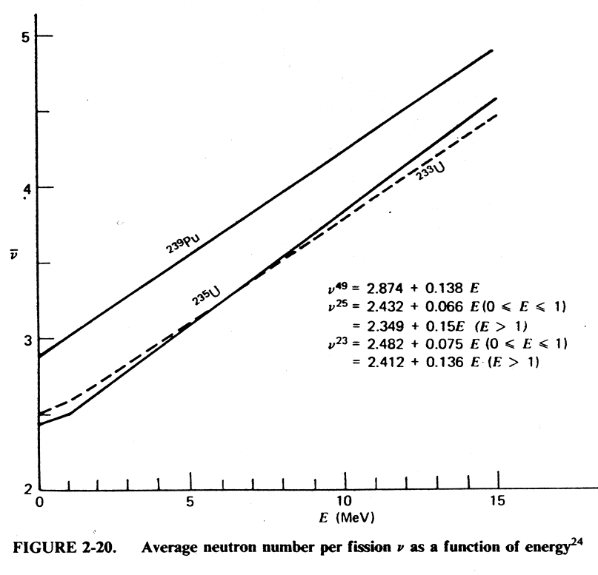

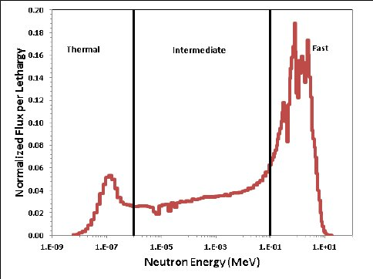

Q 11) Explain the Self-Shielding effect on heterogeneous reactor core configuration.

**Exam Number 8**

**Subject: Nuclear Reactor Thermal Hydraulics**

**Number of Questions: 7**

**Number of Sub-questions:16**

**Q1)**

There is a flow through two parallel horizontal pipes branching and ending at the same points. The average pressure in the system is about 70 bar.

Pipe 1 carries single-phase liquid water at 286oC while Pipe 2 carries mixture of water and steam at the same temperature with void fraction 80%.



Derive a relationship between the liquid mass flow rate in pipe 1 and the mixture flow rate in pipe 2. Assume homogeneous flow.

**Q2)**

Water flow rate of 0.0754 kg/s is pumped through a uniformly heated vertical pipe. The heat is supplied by an electric heater of 1 MW/m2 capacity. The water pressure inside the pipe is 100 bar (assumed constant) and the inlet temperature is 265oC. The pipe diameter and length are 8 mm and 2.1 m, respectively. Determine if dryout is precluded or not. Find the following values:



1. Mass flux (kg/m2s )
2. Inlet quality
3. Exit enthalpy
4. Exit quality
5. CHF value from loop-up table below
6. Is dryout precluded or not?

Look-up table for CHF (kW/m2)



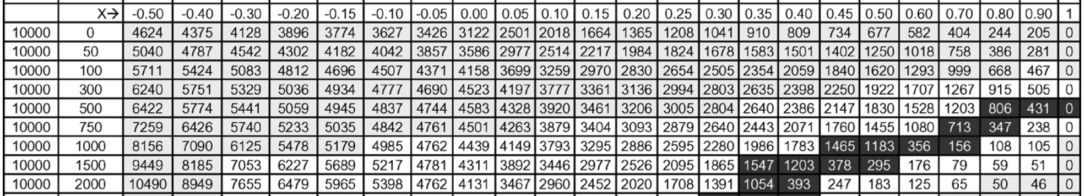

**Q3)**

For a fuel rod with length 3.7 m, pellet diameter 10 mm, no center hole, clad inner diameter 10.1 mm, and clad thickness 0.65 mm.

(a)Derive the change of the fuel temperature with time if the generated heat is 60 kW/m and the rod is cooled by light water at 630oC and the clad to coolant HTC is 1.6 kW/m2K. Use the Lumped approach assuming the fuel initial temperature is equal to the coolant temperature.

(b) According to the safety analysis report, the cladding starts to oxidize when the cladding temperature is higher than 1200 oC. What is the fuel steady-state temperature(oC) when coolant temperature reaches at 630 oC. Is fuel damaged or not? The UO2 and Zircaloy specific heats are 0.3 and 0.4 kJ/kgK, respectively. The density of UO2 without pores and Zircaloy are 10980 and 6550 kg/m3, respectively.





250oC

3.7 m

10 mm

10.1 mm

0.65 mm

**Q4)**

Calculate the mass flow ratefor the thermosiphon loop shown below if all pipes have length of 3 m and inner diameter of 1 cm. Pipes 1 and 3 are vertical while pipes 2 and 4 are horizontal. The loop is filled with water at atmospheric pressure (0.1 MPa) and the water temperature is 100oC in all pipes. Q1 was sufficient to cause boiling in pipe 1 with average quality 20% over pipe 1 length. The steam bubbles continued to flow in pipes 2 but completely condensed at the beginning of pipe 3. We assume homogeneous flow in the two-phase region. Remember for steam-water flow the two-phase density is: 

* At P = 0.1 MPa and T = 100oC, ρ_water = 958.47 kg/m3 , ρ_steam = 0.58967 kg/m3
* In pipes 1 & 2 (boiling = Two phase flow), x = 20%, homogeneous flow
* In pipes 3 & 4 (Single phase flow)
* The friction coefficient for all pipes is 0.02.

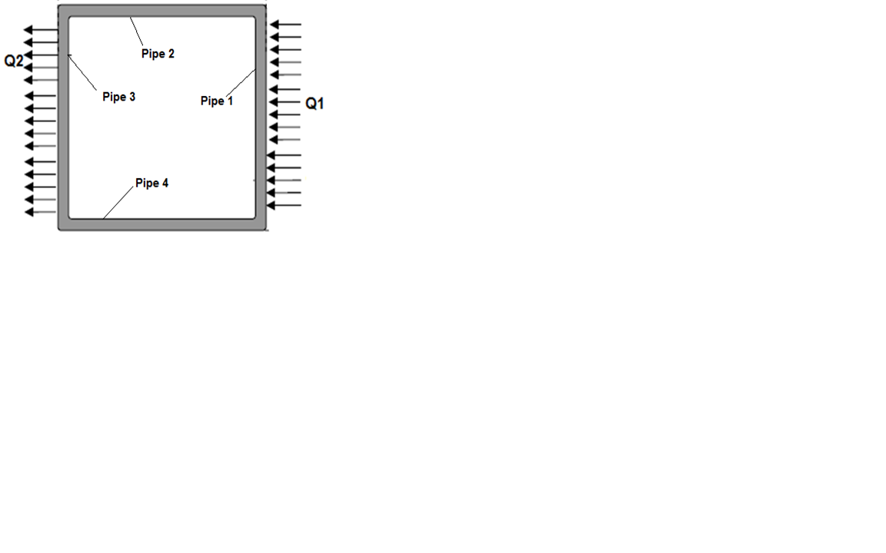

**3 m**

**Q5)**  A hot cylindrical rod with 12 mm diameter, 4 m length and constant surface temperature of 310oC is placed in flowing water. The water temperature and HTC were 60oC and 35 kW/m2K, respectively.

1. Calculate the heat transfer rate in kW from the rod to the water.
2. If the rod was placed in flowing air at the same water temperature, would the heat transfer will be larger or smaller? and why?
3. If the same hot rod which has surface temperature of 310 oC is placed inside a hollow copper cylinder (known as a sleeve) that has the same length as the rod (4 m) and its inner diameter equal to the rod outer diameter (12 mm) and its outer diameter is 100 mm. The sleeve outer surface temperature was kept at 60oC. Calculate the heat transfer from the rod. Note that the copper thermal conductivity is 54 W/mK.

**Q6)**

Calculate the expected steady-state value of the flow rate

* Assuming the flow was initially at rest given that the pump head at steady state is 85.3 m
* assuming that the form loss coeff. at reactor ( KR) and SG (KSG) are 18 and 52, respectively, and the friction loss coeff. at pipe ( f ) is 0.015.
* Assume the pump inlet and outlet are at the same elevation and have the same area.
* assume compressible flow.
* Density = 1,000 kg/m3

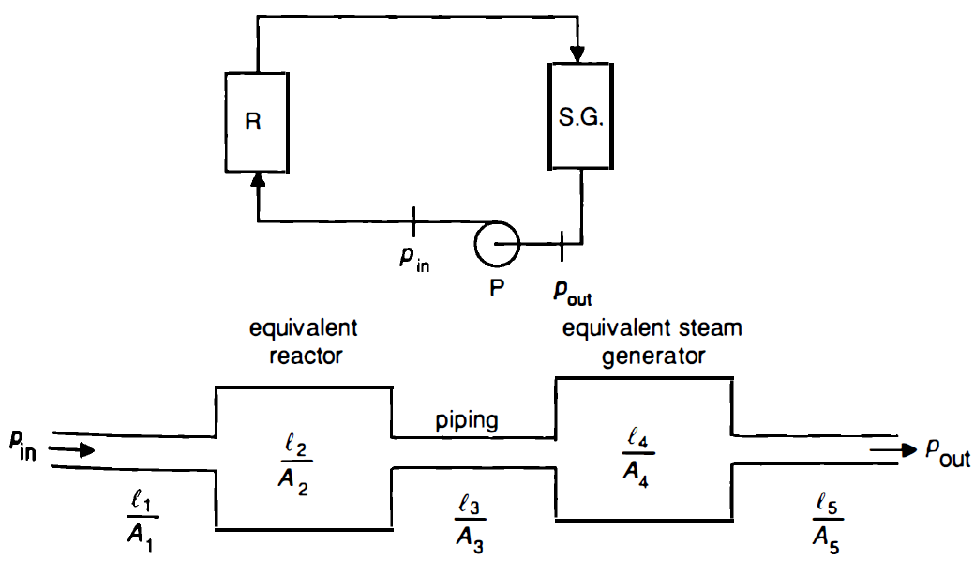

**Q7)**  Water enters an evaporator with a quality of 20% and flows through a vertical pipe with a diameter of 20 mm and length of 4.5 m. Heat is added uniformly along the pipe length with a gradient of 15 kW/m. The pressure at the pipe inlet was 7 MPa and the mass flux is 600 kg/m2∙s. Please assume that pressures at inlet and exit are same and use the data below.

1. Determine the flow regime at the inlet using Taitel et al. map flow regime map. Please draw the line in the figure at the answer sheet and mark the exact points.
2. Calculate the void fraction at the pipe exit

